Press release
02nd June 2015

Showcase for the donumenta in Bucharest

With its international exhibition project, ‘14 x 14 –Survey of the Danube Region.’ in Romania, the renowned cultural operator will be breaking new boundaries.

14 x 14 – Survey of the Danube Region. Positions in Contemporary Art.

- 12th June - 12th July, 2015,
- MNAC Anexa – National Museum of Contemporary Art, Bucharest (Romania)
- Special presentation:
Informal Occurrences - Compendium of Spontaneous Vegetation,
a project by Nona Inescu & Dragoș Petrișor & Mihaela Vasiliu currently studying with Alexandra Croitoru at the Photo-Video department of The National University of Arts in Bucharest.

Regensburg / Bucharest – donumenta continues its journey through South - and East Europe: June 12th - July 12th, 2015
„14 x 14 – Survey of the Danube Region. – Positions in Contemporary Art.“
will be shown in MNAC Anexa – National Museum of Contemporary Art in Bucharest in Romania.
Alexandra Croitoru, internationally renowned artist of Romania, invited her students from the Photo-Video department of The National University of Arts in Bucharest to develop a project, which will be shown as a special contribution in the exhibition.

In the exhibition now to be shown in the MNAC Anexa - Museum of Contemporary Art of Bucharest, 14 contemporary, internationally renowned sculptors, painters, installation and media artists as well as a photographer reflect the realities, experiences and utopias of their home countries in 26 snapshots.

Each artist has provided two photographs. These were made on invitation of Regina Hellwig-Schmid, director and curator of the donumenta: According to her, “the formula ’14 x 14 – Survey of the Danube Region.’ expresses our invitation to the people of Europe to choose art as a parameter to take up the example of the Danube region to discover and reflect on individual, European and global realities and visions.”

The exhibition ’14 x 14 – Survey of the Danube Region.’ was curated by Regina Hellwig-Schmid, artistic director and project manager of donumenta since 2003.
“14x14“ was already presented in four different countries of the Danube Region: Germany (Edwin Scharff-Museum Neu-Ulm), Serbia (Museum of Contemporary Art Novi Sad), Hungary (Pécsi Gallery) and Austria (Palais Porcia Bundeskanzleramt Vienna).
According to the donumenta exhibition concept at each place young artists are invited to contribute.
Alexandra Croitoru, one of the most important artists of Romania´s art scene developed with her students Nona Inescu, Dragoș Petrișor and Mihaela Vasiliu for this exhibition the project
„Informal Occurrences – Compendium of Spontaneous Vegetation“.

Informal Occurrences - Compendium of Spontaneous Vegetation is an observational project consisting of a series of photographs and a publication documenting the instances of spontaneous urban vegetation in and around Bucharest. This “compendium” does not present a comprehensive research on the matter, but rather a subjective study of several botanical species, informally known as “weeds”. These plants are resistant, often thriving in hostile conditions with very little soil or direct sunlight. They grow in the cracks between paving stones, concrete walls or on waste ground in the city; their presence is constant despite being overlooked by the majority of passers-by. Consequently, this project seeks to alter the perspective upon this phenomenon, citing the environmental
benefits by focusing on this frequently ignored ecology. As an addition to
the photographic documentation, several urban species were selected,
identified and presented as a “botanical atlas”.
MNAC – National Museum of Contemporary Art in Bucharest, Romania was founded in 2001 from the Romanian Government. Since 2004 it is situated in a wing of the Palace of Parliament and different other places and developed since then to one of the most important museums for contemporary art of Eastern Europe. The museum is internationally cooperating and working with different institutions worldwide. It´s main focus and interest lies on international dialogues about art and society.

Since 2006 donumenta collaborated already in different projects with Romania and the artist Alexandra Croitoru.
2007 Romanian art and culture was in focus of donumenta in Regensburg and in 2012 for the jubilee exhibition „14 x 14 – Survey of the Danube Region. Positions in Contemporary Art.“

donumenta, one of the most well-known initiatives in current art and culture in and from the countries of the Danube Region, will be breaking new boundaries in the town of Bucharest. From June 12th 2015, under the formula ’14 x 14 – Survey of the Danube Region. – Individual Views.’, donumenta will be presenting for four weeks photographic works from outstanding artists from the 14 countries of the Danube region. It is not simply that new and unusual viewpoints of the individual countries of origin are conveyed. With this exhibition project, the donumenta, under the highly acclaimed director and curator, Regina Hellwig-Schmid, is able to carry on its international cultural work begun in 2003 in furthering the networking of society in the Danube Region, a society in transition.

Sponsored by the Bavarian State Government and the city of Regensburg, donumenta developed its international exhibition project, ’14 x 14 – Survey of the Danube Region’ in the year 2012 in Regensburg on the occasion of the 10th anniversary of the beginning of its widely acclaimed intercultural engagement for artists in the Danube Region. The focal point is the development and promotion in the EU macro region of international artistic events in close curatorial co-operation with museums, galleries and artists. In 2007, within the framework of a festival lasting several weeks, the donumenta devoted itself to the whole range of art and culture in Romania.
With the formula ’14 x 14’ the focus of the donumenta is now on the capability of the artists to take on responsibility and use their imagination to create new realities. Working on the premise that it is the artist who, in his work, surveys the world anew, the unprejudiced look at those who are different, and that which is different opens up new perspectives. In this context, the macro region ‘Danube’ with its 14 countries, proves to be an enormous laboratory with unique development possibilities for Europe.
In the exhibition now to be shown in the MNAC Anexa Museum of Contemporary Art of Bucharest, 14 contemporary, internationally renowned sculptors, painters, installation and media artists as well as a photographer reflect the realities, experiences and utopias of their home countries in 26 snapshots. Each artist has provided two photographs. These were made at the invitation of Regina Hellwig-Schmid, director and curator of the donumenta: According to her, “the formula ’14 x 14 – Survey of the Danube Region’ expresses our invitation to the people of Europe to choose art as a parameter to take up the example of the Danube region to discover and reflect on individual, European and global realities and visions.” In 2004 Frau Hellwig-Schmid was awarded the title ‘Woman of Europe’ by the German European Movement.

Background information is to be found on pages 4 and 5.

Kindly supportet by the City of Regensburg and the MNAC Bucharest.

14 x 14 – Survey of the Danube Region.
Positions in Contemporary Art.
14 individual views – 14 artists – 14 countries of the Danube Region

Artists: Alexandra Croitoru, Romania | Ivan Bazak, Ukraine | Pavel Brăila, Moldova | Anetta Mona Chişa & Lucia Tkáčová, Slovakia | István Csákány, Hungary | Biljana Djurdjević, Serbia | Igor Grubić, Croatia | Pravdoliub Ivanov, Bulgaria | Magdalena Jetelová, Czech Republic | Mladen Miljanović, Bosnia & Herzegovina | Julian Palacz, Austria | Lazar Pejović, Montenegro | Tadej Pogačar, Slovenia | Herbert Stolz, Germany

Special Guests:
Nona Inescu, Dragoș Petrișor and Mihaela Vasiliu, Romania | presenting a new project developed with Alexandra Croitoru at the National University of Arts Bucharest

Curator:
Regina Hellwig-Schmid, artistic director of donumenta und “14x14”

Place: MNAC Anexa, National Museum of Contemporary Art
Calea Moșilor 62-68, Bucharest
Duration: June 12th – July 12th, 2015
Opening: Friday, June 12th, 7 pm
Calin Dan, director MNAC
Regina Hellwig-Schmid, curator donumenta
Nona Inescu, contribution project of the students

Website: www.mnac.ro

Opening Hours:
Wednesday – Sunday, 10am - 6pm

photos:

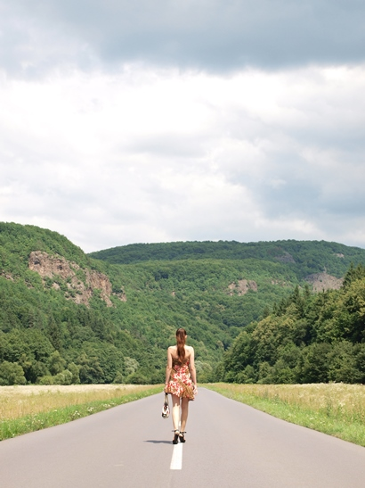

Anetta Mona Chişa & Lucia Tkáčová Two Women on the Road, 2012, 01/02

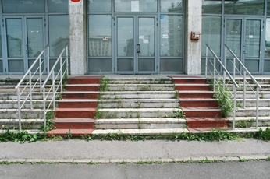
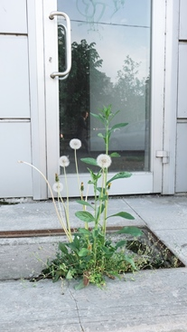
Mihaela Vasiliu, Dandelion, 2015 Dragos Petrisor, Post office, 2015 Informal

Press Review – Background

02nd June 2015

Since 1992 Regina Hellwig-Schmid has been involved in the promotion of international understanding. Her first international project with the countries on the banks of the Danube in the year 2000 was pax danubiana – a message in a bottle for peace. 1857 artists from the 10 Danube countries took part. This was followed in 2001 by the first International Danube Conference for Art and Culture in Regensburg with the emphasis on Serbia. Under the honorary presidency of Regina Hellwig-Schmid, the 2nd International Danube Conference for Art and Culture took place in 2003 in Belgrade. In 2003, Hellwig-Schmid began with the donumenta, a series of festivals which continued until 2011 and in which each year the current art and culture across all genres from one of the countries along the Danube were presented to the German public. For her work in the field of peace-promoting, Regina Hellwig-Schmid received many national and international acclamations. The German European Movement awarded her the title of Woman of Europe 2004, the Bavarian Volksstiftung honoured her in 2005 for her engagement, in 2006 she was awarded the medal for special merit in Bavaria in a united Europe and in the same year, for her remarkable contribution to the popularization of art and culture in Bulgaria, she received a diploma and a medal.

In the years from 2003 to 2011, the donumenta e.V. presented contemporary art from the countries along the Danube. Following the geographical flow of the river, the donumenta presented each year the spectrum of art and culture from a different country and in this way set off a continuing dialogue about identity and community in an expanding Europe: Ukraine (2003), Moldova (2004), The Republic of Bulgaria (2005), the Republic of Austria (2006), Romania (2007), Croatia (2008), Slovakia (2009), Hungary (2010), Serbia (2011). In 2012, the EU Strategy for the Danube Region in mind, donumenta e.V. extended its area of action to include all 14 countries of the Danube basin and for the first time in Germany on the occasion of its 10th anniversary under the formula ’14 x 14 – A Survey of the Danube Region.’ presented works of the most internationally renowned artists of all the countries within the framework of an exhibition lasting several weeks in addition to an international symposium under the title ‘ Danube – Whereto?’
Since 2013 under the same formula, there have been an increasing number of exhibitions and events organized by the donumenta in countries of the Danube region.

Kindly supportet by the City of Regensburg and the MNAC Bucharest.

